Unity project streaming on Oculus Quest 2

Created by Linfeng Wu, updated on 08/11/2023

Instructions for streaming a Unity project on Oculus Quest 2.

Note: The previous SOP about Unity and Oculus Integration plugin showed how to create a Unity project using Oculus Integration. This SOP is a follow up to illustrate how to stream a Unity project on the device (Oculus Quest 2). The steps will start from the Unity project created in the Unity and Oculus Integration plugin SOP.

Downloads:

Oculus app for desktop: <https://www.meta.com/help/quest/articles/getting-started/getting-started-with-rift-s/install-oculus-pc-app/>

Required Items: Oculus Quest 2; Link Cable.

Steps:

1. Set up the Unity project as described in the Unity and Oculus Integration plugin SOP.

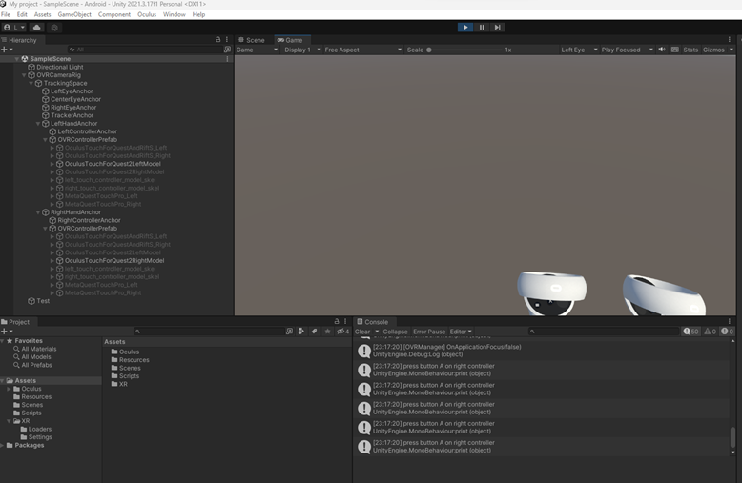

1. Connect Quest 2 to the Oculus app.

* Plug USB-C cable into Quest 2 and plug the other end into computer.
* Put on Quest 2 and select **Always allow from this computer** and **Allow** on the respective prompts.
* Quest 2 should now be connected as indicated as **Active** and **Connected**.

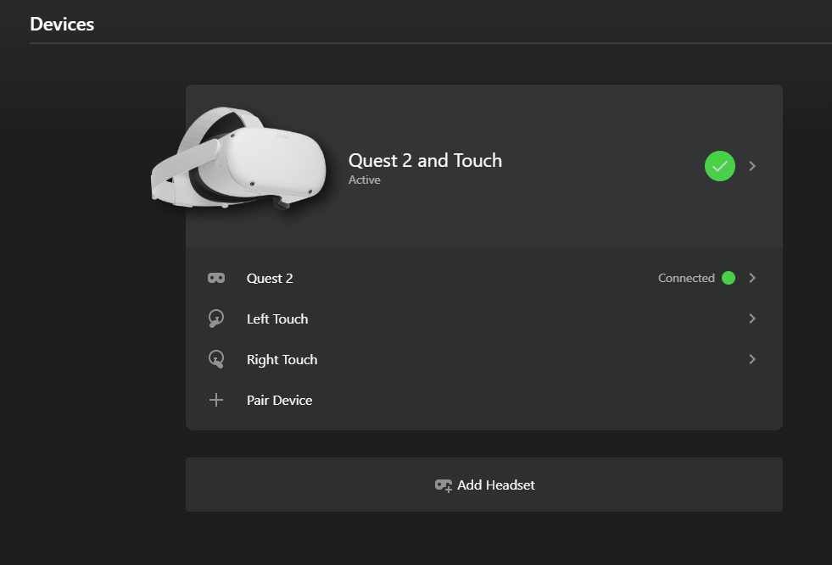

1. Set up the Oculus app.

* Go to settings -> General, enable Unknown Sources, Set Oculus as active under OpenXR Runtime.

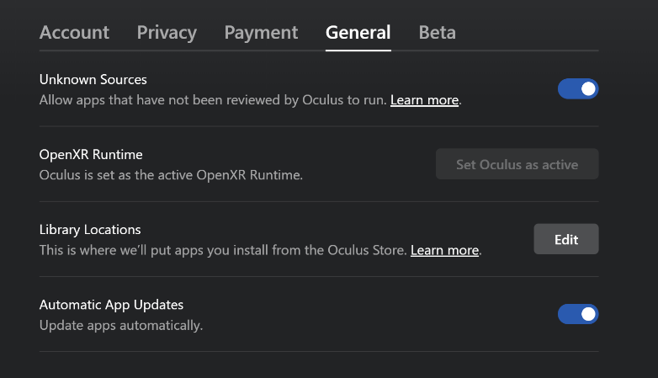

* Go to settings -> Beta, enable Developer Runtime Features.

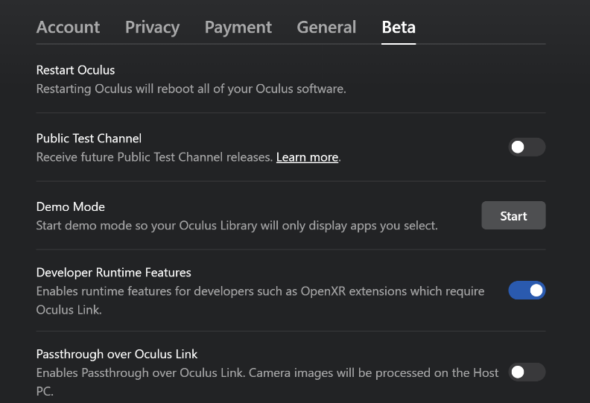

1. Enable quest link through Quest 2.

* Put on your headset and go to Settings-> System -> Quest Link
* Select the toggle next to Quest Link to enable access to Link. It should now also appear in the quick settings menu. Select Launch Quest Link.
* Select Enable when you see the **Enable Oculus Link** pop-up. The following third picture shows how it looks when Oculus Link is enabled.

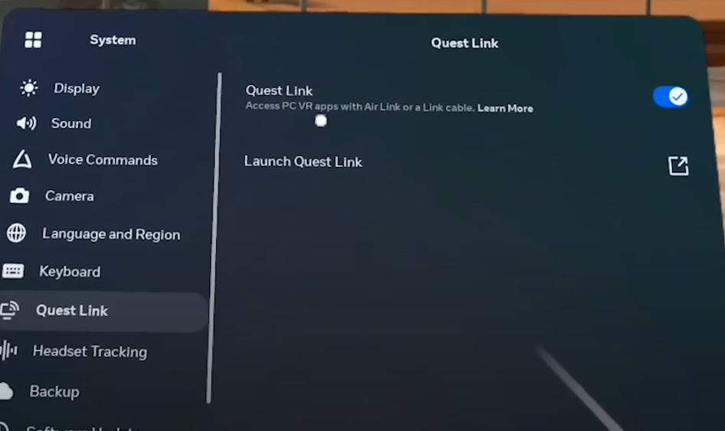

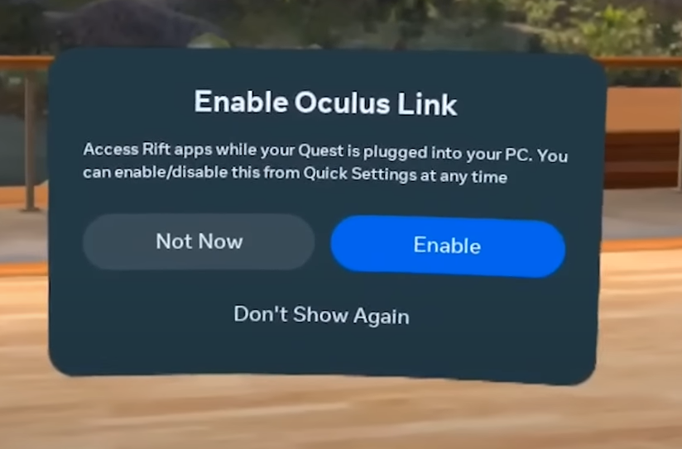

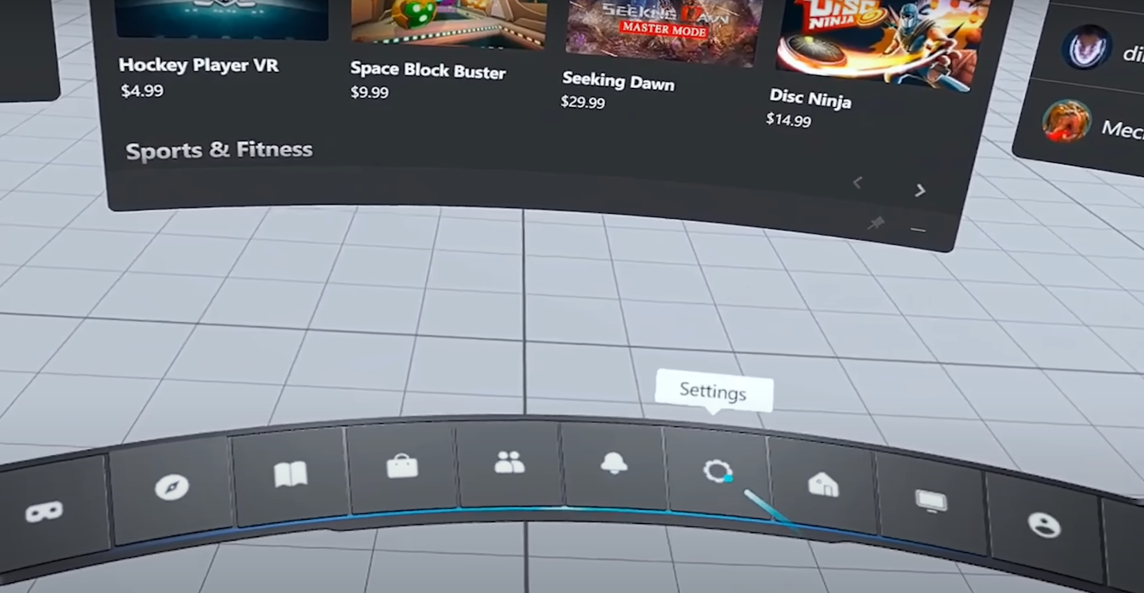

1. Stream the Unity project to Quest 2 by hitting the play button in Unity. The Game view shows how it looks in Quest 2.

